***Binary Maze Challenge***

1. ***Initial Binary Number :***

1100101011110010

1. ***Logic Gates room :***

1100101011110010 AND 1010110010101101 gives 1000100010100000

1000100010100000 OR 0111001100110011 gives 1111101110110011

1111101110110011 XOR 1101110111001110 gives 0010011001111101

0010011001111101 NOT gives 1101100110000010

1. ***Binary Conversion Room :***

Converting 1101100110000010 into decimal form gives 55,682

On adding 123 it gives 55,805

Multiplying 55,805 with 7 gives 3,90,635

On converting 3,90,635 to decimal we get 1011111010111101011

1. ***Weighted Binary Balancing :***

1001, 1100, 1110, 1010, 0111, 0101, 0011, 1111,1101, 1011, 0110, 0100, 0010, 0001,

and one unknown heavier binary number.

By wight checking (i.e. if we check the number of one’s in each number )

We can say that 1111 is the heaviest which is 15..

We can also do this by dividing the numbers into two parts and check and divide the

heavier part again

1. ***Binary Tree Navigation*** : Number 10111

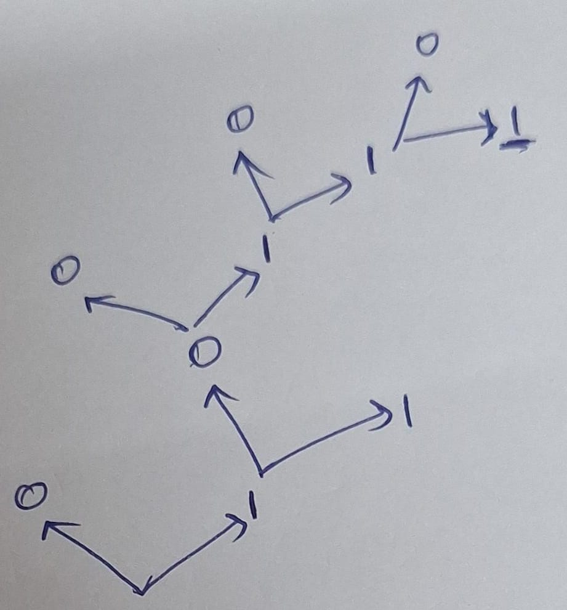

1. ***Binary Sequence Game*** :

10101011010100101110 is the initial number

We can get all 1’s by flipping 3 bits at a time

Minimum moves required would be 3

1. ***Binary Palindromes*** :

number 1011011101

if we flip the 5th bit we get a palindrome

1011111101

Orelse , we can also flip the 6th bit

1011001101

1. ***Complex Binary Patterns:***

1. 1111000000 -- 960

2. 1110100000 -- 928

3. 1110010000 -- 912

4. 1110001000 -- 904

5. 1110000100 -- 900

6. 1110000010 -- 898

7. 1110000001 -- 897

8. 1101000001 -- 833

9. 1100100001 -- 801

10. 1100010001 -- 785

11. 1100001001 -- 777

12. 1100000101 -- 773

13. 1100000011 -- 771

14. 1010000011 -- 643

15. 1001000011 -- 579

16. 1000100011 -- 547

17. 1000010011 -- 531

18. 1000001011 -- 523

19. 1000000111 -- 519

20. 0100000111 -- 263

21. 0010000111 -- 135

22. 0001000111 -- 71

23. 0000100111 -- 39

24. 0000010111 -- 23

25. 0000001111 -- 15

26. 0000011110 -- 30

27. 0000111100 -- 60

28. 0001111000 -- 120

29. 0011110000 -- 240

30. 0111100000 -- 480

31. 1101100000 -- 864

32. 1100110000 -- 816

33. 1100011000 -- 792

34. 1100001100 -- 780

35. 1100000110 -- 774

36. 1011100000 -- 736

37. 1001110000 -- 624

38. 1000111000 -- 568

39. 1000011100 -- 540

40. 1000001110 -- 526

41. 0110000011 -- 387

42. 0011000011 -- 195

43. 0001100011 -- 99

44. 0000110011 -- 51

45. 0000011011 -- 27

46. 0111000001 -- 449

47. 0011100001 -- 225

48. 0001110001 -- 113

49. 0000111101 -- 61

50. 0010101010 -- 170

51. 0101010100 -- 340

52. 1010010010 -- 658

53. 1000101010 -- 554

54. 1010001010 -- 650

55. 1010100010 -- 674

56. 1010101000 -- 680

57. 1000001011 -- 523

58. 1000010011 -- 531

59. 1000100011 -- 547

60. 1001000011 -- 579

61. 1010000011 -- 643

1. ***Binary XOR Pairs with Constraints :***

101010, 011011, 110100, 001101,100110, 111111, 000000

The two numbers in the array whose XOR gives the maximum result are 110100 and 000000

and the pair chosen does not have more than three consecutive '1's in their binary

representation.

1. ***Binary Multiples and Remainders :***

The number 1101010 is not a multiple of 7

Algorithm :

Step1 : Convert the binary number to decimal

Step2 : And check the number mod 7